Inventory Count Application Process Overview & Functional Specs
M. Pakron 05/10/2011
Table of Contents
Project Synopsis: 2
Business Rules and Assumptions: 3
Information Architecture 3
Functionality Overview: 3
Security 3
Screens: 5
Home (Default screen for Submitters and Managers) 5
Count Sheet Entry (Submitters and Managers) 8
Home (Admin) 15
Messages 17
Create New Message 19
Edit Message 21
Count Periods 23
Create Count Period 25
Edit Count Period 27
View User Access 29
Request User Access 31
Upload Count Directions 33
Bulk Data Upload 35
Admin View Data 37
Admin Add/Update Items 40
Search for Item 43
Change Log: 46

Project Synopsis:
Each quarter, locations are required to count their inventory and then submit this data to the Accounting team. The existing process in completely manual and requires a customized spreadsheet be created and sent to each location by Accounting. A counter at each location then uses the spreadsheet to count their inventory. Inventory counts are then added to the spreadsheet, which is sent back to Accounting.
The manual process is time-consuming for Accounting and often results in data integrity issues, such as missing counts for items, or erroneous counts. On occasion, counts are submitted in unsupported formats such as PDF. A high percentage of locations also routinely submit their counts late. There is no current method for tracking count submissions.
The new web application will have several functions that aim to automate the inventory process and to increase the quality of the data:
- The application will automate the quarterly count sheets for each location
- The application will provide online submission and validation of inventory counts
- The application will provide for a method for counts to be approved by managers before being submitted to Accounting
- The application will provide online tracking of count submissions per location
- The application will provide admins with the ability to customize count periods and create custom messages per location.

Business Rules and Assumptions:
- No item on a count sheet can be submitted without at least a zero count.
- A facility may only submit one count sheet per count period.
- An item may only display once per count sheet per facility per count period.
- Only one user may check out a count sheet for a location at a time. Admins can override this checkout if need be. Entry sessions will be limited to a specified idle time frame (TBD) and will force a check-in after this timeframe has been reached.
- One day after a count period due date, the system will email facility managers whose facilities have either not submitted or approved their counts.
- The system automatically captures the cost for an item upon manager approval of a count period and upon the “I’m Done Adding Items” button on the Add/Update Items screen.

Information Architecture

Functionality Overview:

Security
There will be three security groups used with the following user types:
- Admin: Accounting (Rachel’s group)
  - Messages (add, edit, delete), Upload Count Directions, Count Periods (add, edit, delete), User Access (view, request access/changes), Track Submissions (view tracking, send reminders), Count Data (view, add items, add comments)
  - Access to raw data either through SQL tables or a cube
- Managers
  - Count Sheets (Approve, Reject, Submit)
  - Print Directions and other Useful Files
- Submitters: (counters/submitters)
  - Count Sheets (Add count data, Submit)
  - Print Directions and other useful files

Screens:

Home (Default screen for Submitters and Managers)
Page Content and Business Logic:
Screen is the main entry for the application for Submitters and Managers.
Functional Requirements:
- Screen displays user’s name and link if displayed name is incorrect to log out and log back in to the system.
- If user has access to more than one facility, screen will provide user with ability to choose a facility to work with. If user is assigned to only one location then the screen will default to that location.
- Screen will display the current count period, inventory count date, and due date.
- Screen will provide user with ability to enter the names of employees who are performing the physical count. Users will also have the ability to remove added names.
- Any current messages assigned to the selected location will display on the screen.
- Screen will display links allowing user to Print the Current Count Sheet, Print the Count Sheet Directions, Enter Count Data, and Print All Other Available Codes.
- Screen will display relevant count sheet status messages such as indicating what the overall status of the count sheet is: Not Started, Saved, Submitted, Approved, Rejected; screen will also indicate if the count sheet is currently checked out and locked for editing.
- If Submitter tries to enter the current count sheet before the Count Date a message will display reminding the Submitter to be mindful of any inventory changes that may occur from the current date and the Count Date. All changes must be accounted for in the count sheet before it can be submitted.
User Flow:
- If user is assigned to more than one facility, user selects a facility.
- The current open count period details will display onscreen.
- User enters in the names of the users who are performing the physical count. Existing counters can be removed, if necessary.
- User reads the messages assigned to the selected facility.
- User prints the current count sheet and gives to counter to fill out.
- User prints out the most current count sheet directions.
- Once manual count has been completed, user clicks the Enter Count Sheet Data link.
Fields and Buttons:
Field/Button | Comments | Required
Select Facility | Droplist of all facilities that the user has access to. If user is only assigned to one facility droplist will not display. a message | If it displays, Yes
Employee(s) Performing Physical Count | User enters in names of users who are performing the physical count one name at a time. | No
Add Employee button | Button adds the entered employee name to the Employees Performing the physical Count list. | No
Remove link | Link displays next to names of employees added to the Physical Count list. Clicking link will remove the employees name from the list. | No

Business Rules:
- If the selected facilities count sheet has been checked out, an alert will display, and the count sheet cannot be edited until it has been checked in. Only the user who has the count sheet checked out can edit the count sheet.
- If a selected facilities count sheet has been submitted it is not editable unless it is rejected by either a manager or an admin.
- Users may start working on a count sheet one week before the count date but cannot submit the count sheet until the due date.
- Users may submit the count sheet until the count period has been closed by the admins.
Navigation:
This describes the global navigation available throughout the application for Submitters and Managers
If Submitter/Manager:
- Enter Count Sheet Data: routes to Count Sheet Entry where user can enter in count sheet counts
- Print All Other Available Codes: Routes to an Excel file that lists all active inventory not currently listed on the selected facilities Count Sheet.
- Print Count Sheet: routes to an Excel file of the current count sheet inventory. Data will mirror the Enter Count Sheet tabs; all counts are blank to allow manual entry.
- Print Count Sheet Directions: routes to a file of the Count Sheet Directions, which can be saved and printed.

Screen Layout and Design:
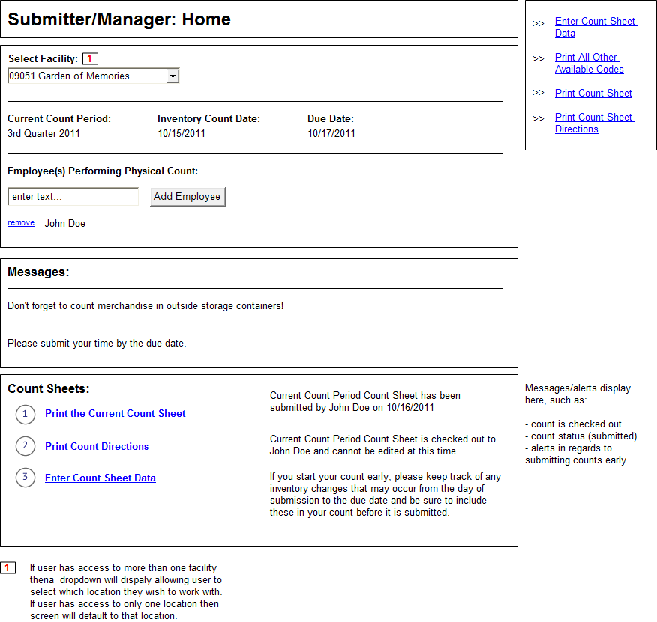

Count Sheet Entry (Submitters and Managers)
Page Content and Business Logic:
Screen displays a specific facility’s count sheet in a web interface that allows online entry of the count data.
Functional Requirements:
- Screen is available to submitters and managers.
- Screen displays the count sheet in a tabbed interface: Main, Special and Additional.
- Data for count sheet is generated from the inventory items in the previous count period’s count sheet for the location; all count values are initially empty.
- Screen displays basic count sheet period information such as period and dates.
- Screen displays three tabs for entering count sheet data: Main, Special, and Additional.
User Flow:
If Submitter
- User enters the counts for the items listed on the Main inventory tab (default tab).
- User checks the box next to each item that should be removed from the count.
- User clicks the Save Main Inventory Count button.
- User clicks the Special tab.
- User enters the counts for the items listed on the Special inventory tab.
- User clicks the Save Special Inventory Count button.
- User clicks the Additional tab.
- Users enter in the HMIS Item code for each item they wish to add. Upon tabbing out, the HMIS Category, HMIS Supplier, and HMIS Item Description columns populate based off the HMIS Item Code.
- User enters in the count for the added item and then clicks the Add button. If user entered the line item in error, they can click the Clear button, which will remove all data from the line.
- Once an item has been added, the user can click the Update button to edit the line item, or they can click the Delete button to remove the line item from the Added Items grid.
- If user does not know the HMIS Item Code for an item they can click the Search for Items button (See Search for Items for details)
- User clicks the Save Inventory Count button.
- If user is ready to submit the count sheet, they click the Submit Count Sheet button.
- If user is not ready to submit the count sheet, they click the Check In button.
- If user clicks the Reset Count Sheet button, a message will display (are you sure? Ok, Cancel); if user selects Ok, all of the data entered in the count sheet will be reset.
- If user clicks the Print button all of the entered count sheet data will display in a printable format.
If Manager
- Steps 1-16 above also apply to managers.
- Once the count sheet has been submitted, the Approve and Reject count sheet buttons will display for managers.
- If the manager approves the count sheet they will click the Approve Count Sheet button.
- If the manager does not approve the count sheet they click the Reject Count Sheet button. The system displays a form that allows the manager to enter a rejection reason. Upon clicking Submit Rejection, the system displays a confirmation alert (are you sure? Ok, Cancel); if Ok, the system changes the status of the count sheet to Rejected-Mgr and emails the Facility users.
Fields and Buttons:
Header area:
Field/Button | Comments | Required
Facility text | Screen displays the selected facility. | na
Current Count Period text | Screen display the current count period. | na
Inventory Count Date text | Screen displays the inventory count date for the selected count period. | na
Due Date text | Screen displays the due date for the selected count period. | na
Open Date text | Screen displays the open date for the selected count period. | na
Employee(s) Performing Physical Count text | Screen displays all of the entered employees who are performing the physical count for the selected count period. | na

Main tab:
Field/Button | Comments | Required
HMIS Category column | Screen displays the HMIS Category for the listed items. | na
HMIS Supplier column | Screen displays the HMIS Supplier for the listed items. | na
HMIS Item Code column | Screen displays the HMIS Item Code for the listed items. | na
HMIS Item Description column | Screen displays the HMIS Item Description for the listed items. | na
Count field | Field allows user to enter in the inventory count for the listed items. Count value must be at least 0. | Yes
Remove? checkbox | Clicking the Remove? Checkbox will inform the system to not display the checked item on future count sheets. | No
Save Main Inventory Count button | Button saves the data entered in the Main tab.
Cancel button | Button removes all entered data from the Main tab entered during the current editing session. | No

Special tab:
Field/Button | Comments | Required
HMIS Category column | Screen displays the HMIS Category for the listed items. | na
HMIS Supplier column | Screen displays the HMIS Supplier for the listed items. | na
HMIS Item Code column | Screen displays the HMIS Item Code for the listed items. | na
HMIS Item Description column | Screen displays the HMIS Item Description for the listed items. | na
Count field | Field allows user to enter in the inventory count for the listed items. Count value must be at least 0. | Yes
Save Special Inventory Count button | Button saves the data entered in the Special tab.
Cancel button | Button removes all entered data from the Special tab entered during the current editing session. | No

Additional tab:
Field/Button | Comments | Required
Search for Items button | Button displays the Search for Item modal screen, which allows the user to search for an item to add by several criteria. See Search for Items for more details. | No
HMIS Item Code field | Button allows user to enter in the HMIS Item Code for an item. Upon tabbing out of the field, the HMIS Category, Supplier and Description columns will auto-populate based off the entered HMIS Item Code. | na
HMIS Category column | Screen displays the HMIS Category for the entered HMIS Item Code. | na
HMIS Supplier column | Screen displays the HMIS Supplier for the entered HMIS Item Code. | na
HMIS Item Description column | Screen displays the HMIS Item Description for the entered HMIS Item Code. | na
Count field | Field allows user to enter in the inventory count for the listed items. Count value must be at least 0. | Yes
Save Additional Inventory Count button | Button saves the data entered in the Additional tab.
Cancel button | Button removes all entered data from the Additional tab entered during the current editing session. | No

Footer area- if Submitter:
Field/Button | Comments | Required
Submit Count Sheet button | Button saves the count sheet data and changes the status to Submitted; system displays confirmation and then routes user to Home. Button should only display if the Inventory Count date has been reached.
Check In button | Button saves the count data and checks the count sheet in, allowing it to be edited by other users. | No
Reset Count Sheet button | Button will display a confirmation alert (are you sure? Ok, Cancel); if Ok, system will reset the count sheet and remove all data entered since the Open Date for the count period. | No
Print button | Button will display the count sheet data in a printable format onscreen. | No

Footer area- if Manager:
Field/Button | Comments | Required
Submit Count Sheet button | Button saves the count sheet data and changes the status to Approved (if user is Manager, the Submit Count button automatically approves the sheet); system displays confirmation and then routes user to Home. Button should only display if the Inventory Count date has been reached.
Check In button | Button saves the count data and checks the count sheet in, allowing it to be edited by other users. | No
Reset Count Sheet button | Button will display a confirmation alert (are you sure? Ok, Cancel); if Ok, system will reset the count sheet and remove all data entered since the Open Date for the count period. | No
Print button | Button will display the count sheet data in a printable format onscreen. | No
Approve Count Sheet | Button saves the data and changes the status to Approved; count sheet is now locked to edits to everyone except Admins. | No
Reject Count Sheet button | Button displays the Reject Count Sheet modal form which allows manager to enter a rejection reason. | No
Reject Count Sheet Reason field | Field allows manager to enter a reason for the count sheet being rejected. Required if displayed. | Yes
Submit Rejection button | Button changes the status to Rejected MGR. System displays a confirmation and sets the count sheet to be editable. All users for the facility will receive an email with the rejection reason. System routes user to Home. | No
Cancel button (on Reject Count Sheet form) | Button cancels the rejection and closes the Reject Count Sheet form. | No

Business Rules:
- The count sheet should only be editable if the Open Date has been reached.
- If the Inventory Count Date has not been reached, users should be able to save only, not submit.
- Once the Inventory Count Date has been reached the Submit button should display.
- Users may submit the count sheet until the count period has been closed by the admins.
- If the user is a manager, the Submit Count Sheet button should also approve the count sheet.
Navigation:
- Submitter and Managers default navigation
Screen Layout and Design:
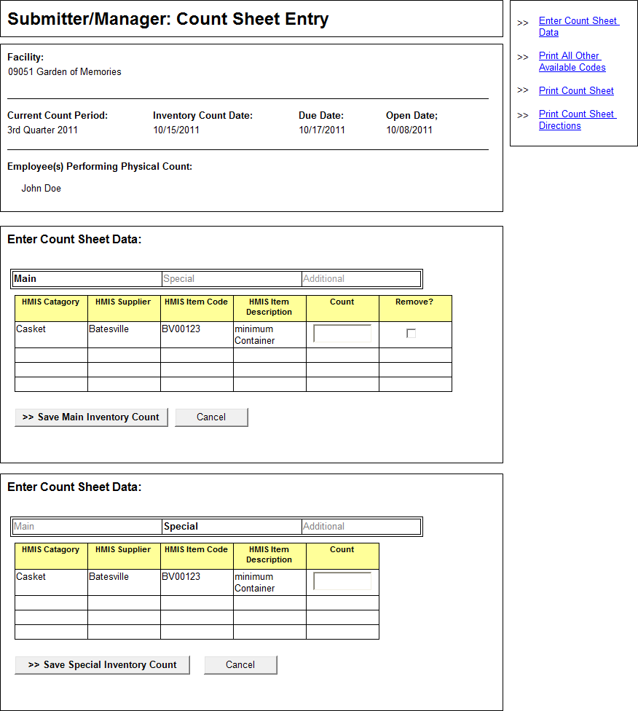
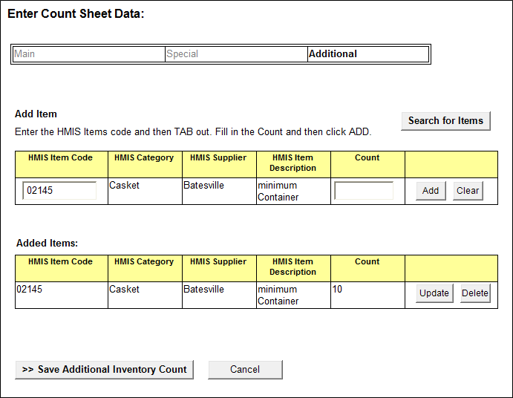

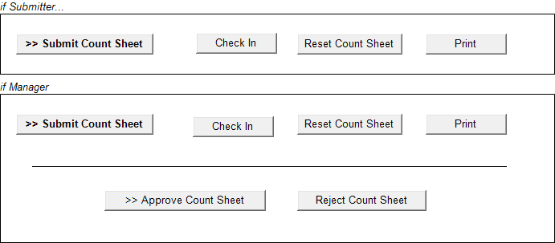

Home (Admin)
Page Content and Business Logic:
Screen is the main entry for the application for Admins.
Functional Requirements:
- Screen displays the submission data for the current count period. Period, Count Date and Due Date are displayed.
- The following fields are prefilled and non-editable: Facility number, Status, Submit Date, Checked Out To.
- If a facility has submitted their count sheet a View Data link will display, which routes to a screen where user may view the data from the submitted facility.
- If a facility has not submitted their count sheet by the Due Date, one day after the count date the system link will send an automated submission reminder to the facilities manager.
- If a count sheet for a facility is currently checked out, the user who the sheet is checked out to will display and an Override link will display, allowing the admin to override the check out and allow the sheet to be editable by other users.
- The following columns are sortable: Facility, Status, and Submit Date, Checked Out To
- Screen will display a form that allows the admin to view the data for a selected count period and facility or all facilities: Choose Count Period, Select Facility, Select All Facilities
- Screen will allow user to create an Excel file of all current Submission Tracking information.
Navigation:
This describes the global navigation available throughout the application for admin users:
- Submission Tracking/Home: routes to admin home where user may view the current periods submissions and can send reminder alerts to facilities
- Messages: routes to a screen where user may add, edit , assign, and delete messages
- Count Periods: routes to a screen where user may add, edit and delete count periods
- Count Directions: routes to a screen allowing the user upload new count directions
- User Access: routes to a screen where the user can view existing access for a facility and request additional access or changes
- View Count Sheet Data: routes to screen that allows user to view data from existing count periods
- Add/Update Count Sheet Data: routes to a screen that allows admins to add new items to facilities and to update existing items.
- Bulk Data Upload: allows the admin to use a preformatted file to upload large batches of data.

Screen Layout and Design:
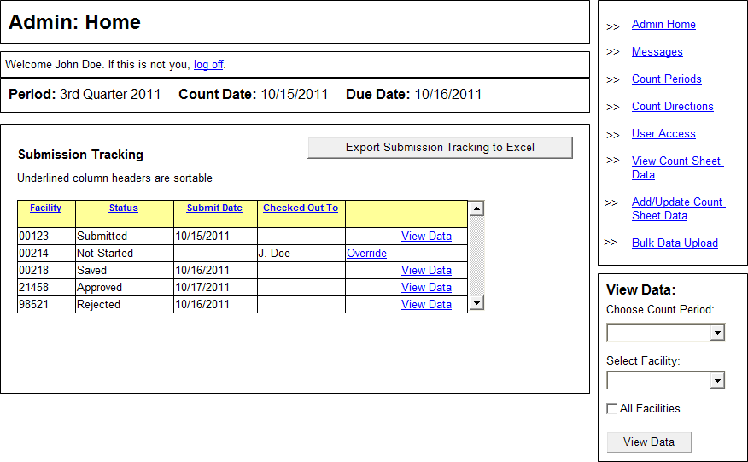

Messages
Page Content and Business Logic:
Screen allows admin users to view existing messages.
Functional Requirements:
- Screen is available to admins only
- Screen displays all added messages for all facilities in the following fields: Facility, Message.
- System provides admin with ability to Edit and Delete existing messages.
- System allows admin to create new messages.
User Flow:
- System displays all existing messages in a grid. User may click the Edit button next to a message to edit it. Clicking Delete will delete the message.
- User clicks the Create New Message button to create a new message.
Fields and Buttons:
Field/Button | Comments | Required
Facilities column | Column lists all of the facilities currently assigned to a message | na
Message column | Column lists all existing messages. | na
Edit button | Button routes user to Edit Messages screen where the existing message data is displayed in editable fields. | No
Delete button | Button displays alert (are you sure? Yes, No); if Yes, system deletes the messages and then displays a confirmation. | No
Create New Message button | Routes user to Create New Message screen. | No

Navigation:
- Admin Navigation
Screen Layout and Design:
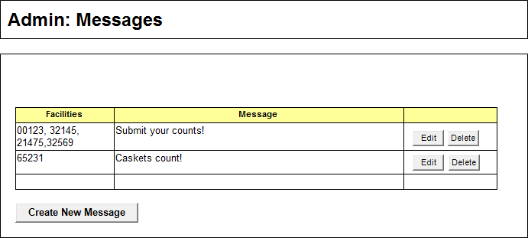

Create New Message
Page Content and Business Logic:
Screen allows admin users to create new messages and assign them to facilities.
Functional Requirements:
- Screen is available to admins only
- Screen allows admin to enter a new message and assign it to all facilities or to selected facilities.
User Flow:
- User types in the new message.
- User selects which facilities should see the message. All facilities can be selected, or individual facilities can be selected.
- All facilities will be listed in a listbox. User may filter the Unassigned listbox by either a full facility number, or by typing a partial number and then a percentage sign, in order to show all facilities that start with those numbers.
- To add facilities, user selects one or more facilities from the Unassigned listbox and then clicks the right-facing button to add the facilities to the Assigned listbox. To remove facilities, the user selects one or more facilities from the Assigned listbox and then clicks the left-facing button to move the facilities to the Unassigned listbox.
- The Create Message button saves the new message. User is routed to the Messages screen.
Fields and Buttons:
Field/Button | Comments | Required
Enter Message | Field allows user to enter in a message. | Yes
All Facilities | If clicked, the message will be assigned to all facilities. | No
Filter by Facility Number | User may add a full facility number or partial facility number followed by a percent sign (05%). | No
Facilities listboxes | All facilities not currently assigned to the message will list on default unless filtered in the Unassigned box . User can select one or many facility numbers and then can click the right facing arrow to add facilities to the Assigned box. All currently assigned facilities for the message are listed in the Assigned box. User may select one of more facilities from this box and can then click the left-facing arrow to remove the facilities from the message. | No
Create Message | Saves the new message; Displays confirmation message; routes user to Messages screen. | No
Cancel | Cancels the new message and routes user to Messages. | No

Business Rules:
- At least one facility must be selected and assigned to the message
- If the All Facilities box is checked, it overrides any selections made in the Facilities listboxes.
Navigation:
- Admin Navigation
Screen Layout and Design:
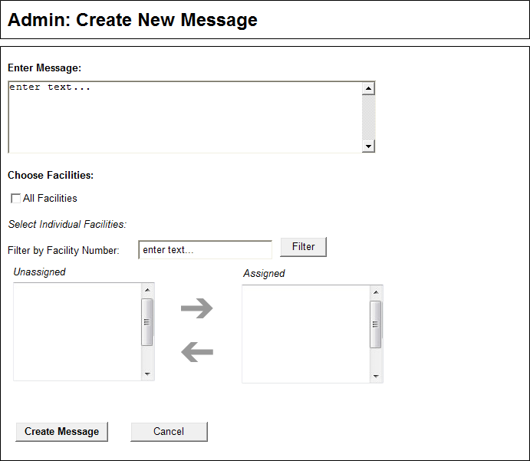

Edit Message
Page Content and Business Logic:
Screen allows admin users to edit existing messages.
Functional Requirements:
- Screen is available to admins only
- Screen allows admin to edit or delete existing messages. Admin selects a message to edit from the Messages screen and that message detail is then displayed here.
User Flow:
- Preselected message displays in editable fields.
- User makes any necessary changes to the message body or facilities and then clicks the Update Message button, which saves the message and routes user back to the Messages screen.
- User may delete the message by clicking the Delete button.
Fields and Buttons:
Field/Button | Comments | Required
Enter Message | Field allows user to enter in a message. | Yes
All Facilities | If clicked, the message will be assigned to all facilities. | No
Filter by Facility Number | User may add a full facility number or partial facility number followed by a percent sign (05%). | No
Facilities listboxes | All facilities not currently assigned to the message will list on default unless filtered in the Unassigned box . User can select one or many facility numbers and then can click the right facing arrow to add facilities to the Assigned box. All currently assigned facilities for the message are listed in the Assigned box. User may select one of more facilities from this box and can then click the left-facing arrow to remove the facilities from the message. | No
Update Message | Saves the message; Displays confirmation message; routes user to Messages screen. | No
Cancel | Cancels the action and routes user to Messages. | No
Delete | Displays an alert (are you sure? Yes, No); if Yes, deletes messages; displays confirmation; routes user to Messages screen. | No

Business Rules:
- At least one facility must be selected and assigned to the message
- If the All Facilities box is checked, it overrides any selections made in the Facilities listboxes.

Navigation:
- Admin Navigation
Screen Layout and Design:
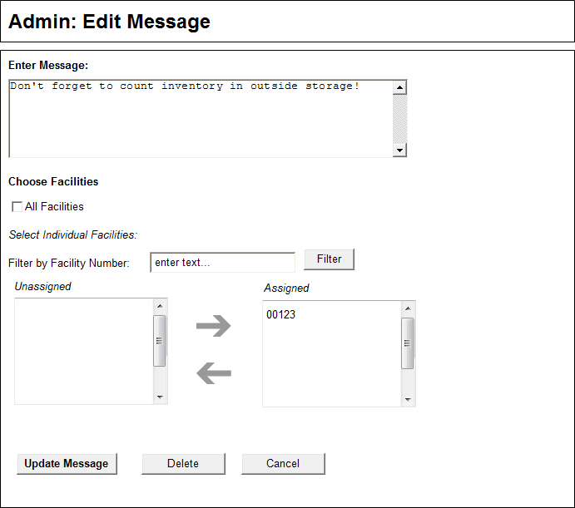

Count Periods
Page Content and Business Logic:
Screen allows admin users to view the existing Count Periods.
Functional Requirements:
- Screen is available to admins only
- Screen allows admin users to view the existing Count Periods and the statuses of each, as well as allow user to edit or close the count.
User Flow:
- User views the count period details for all created count periods.
- User clicks the count period Name link to view the data submitted for the selected count period.
- User clicks the Edit button to edit a count period’s details.
- User clicks the Delete button to delete a count period that does not have any saved or submitted count data.
- User clicks the Close Count button to lock the count period’s data to edits.
- Admin user clicks the Create New Count Period button to create a new count period.
Fields and Buttons:
Field/Button | Comments | Required
Name column | Column lists the name of the count period. | na
Description column | Column lists the description of a count period. | na
Inventory Count Date | Column lists the inventory count date for the count period. | na
Due Date column | Column lists the due date for the count period. | na
Open Date | Column lists the open date for the count period. | na
Status | Column lists the status of the count date: Inactive, Open, and Closed. | na
Edit button | Button routes user to Edit Count Period screen. | na
Delete button | Button displays an alert (are you sure? Yes, No); if yes, system deletes count period. | na
Close Count button | Button closes the count period and locks all users from editing the data for the count period. | na
Create New Count Period | Button routes user to Create Count Period screen. | na

Business Rules:
- Count Period Statuses:
  - Inactive: count period has been created but the open date has not been reached; count period cannot have any data submitted; count period can be deleted.
  - Open: count period has reached the Open Date; data can be saved if Open Date is reached and submitted if Inventory Count date is reached; if no data has been saved or submitted count period can be deleted.
  - Closed: count period has been closed by an admin and cannot be edited in any way by any user level; count period cannot be deleted.
- If user clicks the Create New Count Period button, the system routes user to Create Count Screen and auto-generates the new count period name and description based off of the existing count periods.
Navigation:
- Admin Navigation
Screen Layout and Design:
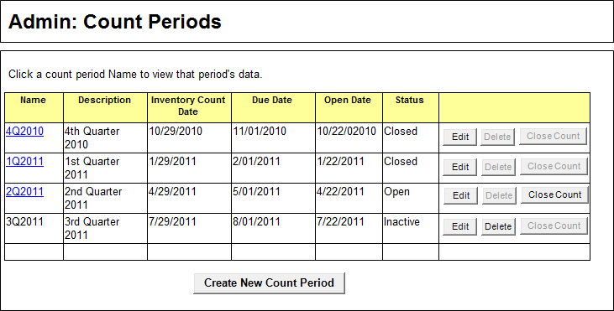

Create Count Period
Page Content and Business Logic:
Screen allows admin user to create a new count period.
Functional Requirements:
- Screen available to admin users only
- Screen allows admin user to create new count periods.
User Flow:
- System auto-generates the next count period name and description. Admin user may edit these if necessary.
- Admin user enters the Inventory Count Date.
- Admin User enters the Open Date.
- Admin user enters the Due Date.
- Admin user clicks the Create Count Period button.
Fields and Buttons:
Field/Button | Comments | Required
Period Name | System auto-generates period name and displays it in an editable field. | Yes
Period Description | System auto-generates period description and displays it in an editable field. | Yes
Inventory Count Date | Field allows user to enter in the Inventory Count Date. | Yes
Open Date | Field allows user to enter in the Open Date. | Yes
Due Date | Field allows user to enter in the Due Date. | Yes
Create Count Period button | Button saves the new count period; system displays confirmation; system routes user to Count Periods screen. | Yes

Business Rules:
- Once the Open Date for a count period is reached, the system changes the count period’s status from Inactive to Open.
- If a count period is open but the Inventory Count Date hasn’t been reached, users may access their count and can save the data but they cannot submit the data until the Inventory Date has been reached.
Navigation:
- Admin Nav
Screen Layout and Design:
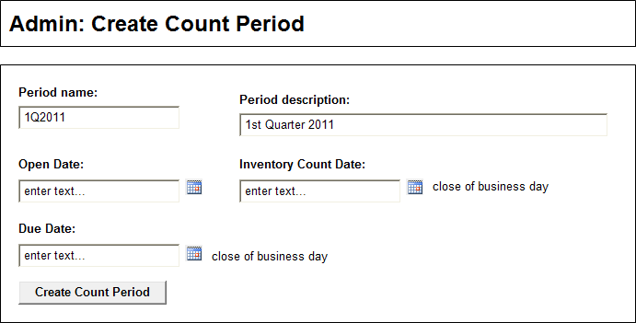

Edit Count Period
Page Content and Business Logic:
Screen allows admin user to edit existing count period information.
Functional Requirements:
- Screen available to admin users only
- Screen allows admin user to edit the information for the count period or delete empty count periods.
User Flow:
- System auto-populates all existing data entered for the count period in editable fields.
- Admin user makes any necessary updates.
- If no count data has been saved or submitted for the count period, the Delete button will display and the Admin User can click the Delete button to delete the count period.
- Once edits are complete, Admin User clicks the Update Count Period button.
- If Admin User needs to cancel the edit they can click the Cancel button.
Fields and Buttons:
Field/Button | Comments | Required
Period Name | System displays previously entered data in an editable field. | Yes
Period Description | System displays previously entered data in an editable field. | Yes
Inventory Count Date | System displays previously entered data in an editable field. | Yes
Open Date | System displays previously entered data in an editable field. | Yes
Due Date | System displays previously entered data in an editable field. | Yes
Update Count Period button | Button updates the count period data; system displays a confirmation message and routes user to the Count Periods screen. | Yes
Delete Count Period button | Button only displays if no counts have been saved or submitted for the count period; system displays alert (are you sure?, Yes, No), is Yes, system deletes count period , displays confirmation, and routes user to Count Periods screen. | No
Cancel button | System cancels the edit and routes the user to the Count Periods screen. | No

Business Rules:
- A count period can only be deleted if no counts have been saved or submitted for that count period.
Navigation:
- Admin Nav
Screen Layout and Design:
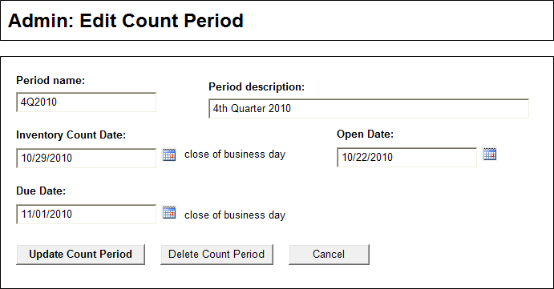

View User Access
Page Content and Business Logic:
Screen displays existing access for a selected user and provides a method for an admin to request additional/change a user’s access.
Functional Requirements:
- Screen is available to admin users only
- Screen allows admin user to select an employee, and view the employees existing access
- Screen provides method to allow admin to request additional access for the selected user
User Flow:
- User selects a user from the Choose User droplist.
- Screen refreshes and the selected user’s name displays and all facilities that the user has access to will display in a grid, along with the user’s access to each.
- User may click the Request User Access Update button in order to request that facilities be added or removed from the selected user’s access.
- User may click the Export Current Access Listing button in order to view and download a Excel file listing of all users who have access to the application, along with the facilities they have access to and the access granted for each.
Fields and Buttons:
Field/Button | Comments | Required
Choose User | List displays all users with network access | Yes
User | Once a user has been selected, the system will display the user’s name. | Yes
Access Listing | All facilities that the selected user currently has access to will display in a grid, along with the access granted for each facility. | Yes
Request User Access Update | Routes the user to the Request User Access screen. | No
Export Current Access Listing | Exports all the current access for all facilities into an Excel file that can be saved or printed. | No

Navigation:
- Admin Nav
Screen Layout and Design:
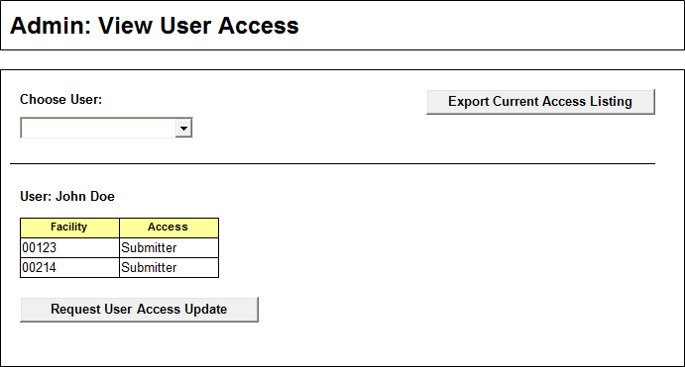

Request User Access
Page Content and Business Logic:
Screen allows admin users to request an employee be assigned or unassigned to certain facilities.
Functional Requirements:
- Screen is available to admin users only
- Screen allows admin to select an employee name and select one or more facilities for that user to have access to. User may also remove facilities that the user currently has access to.
- Screen allows user to filter the facilities list by either a full facility number or partial number.
- Access Request is sent to the ISSO, who will add or remove the requested access and who will then email the user and admins when the action has been completed.
User Flow:
- Preselected user’s name displays on the screen. All current facilities that the user has access to will be listed in the Assigned listbox. All facilities that the user does not currently have access to will list in the Unassigned listbox.
- User may filter the Unassigned listbox by either a full facility number, or by typing a partial number and then a percentage sign, in order to show all facilities that start with those numbers.
- User may add facilities by selecting one or more facilities from the Unassigned listbox and then clicking the right-facing arrow to add the facilities to the Assigned listbox.
- User may remove existing facilities by selecting one or more facilities from the Assigned listbox and then clicking the left-facing arrow to move the facilities to the Unassigned list box.
- If facilities have been added to the Assigned listbox, user then selects which access level should be granted to the selected user for the newly added facilities: Submitter or Manager.
- User then clicks the Submit Access Request button, which sends a preformatted email that lists the selected user, the added and/or removed facilities, and the access levels assigned, to the ISSO group, with the user and the Admin group cc’ed.
- The ISSO will email the user and the Admins once the access has been completed.
- If the user wishes to cancel the action, they may click the Cancel button. The system will then route the user to the User Access screen.

Fields and Buttons:
Field/Button | Comments | Required
User | Auto-displays based on selection from User Access screen | Yes
Filter by facility number | User may add a full facility number or partial facility number followed by a percent sign (05%). | No
Facilities listboxes | All facilities not currently assigned to the user will list on default unless filtered in the Unassigned box . User can select one or many facility numbers and then can click the right facing arrow to add facilities to the Assigned box. All currently assigned facilities for the user are listed in the Assigned box. User may select one of more facilities from this box and can then click the left-facing arrow to remove the facilities from the user’s access. | Yes
Choose Access | User must select one access level to apply to all selected facilities: Submitter or Manager | Yes
Submit Access Request | Sends a pre-formatted email with the User, Facility, and Access information to the ISSO, and cc’s the User and the Admins. | No
Cancel | Cancels the User Request and routes user to User Access screen. | No

Navigation:
- Admin Nav
Screen Layout and Design:
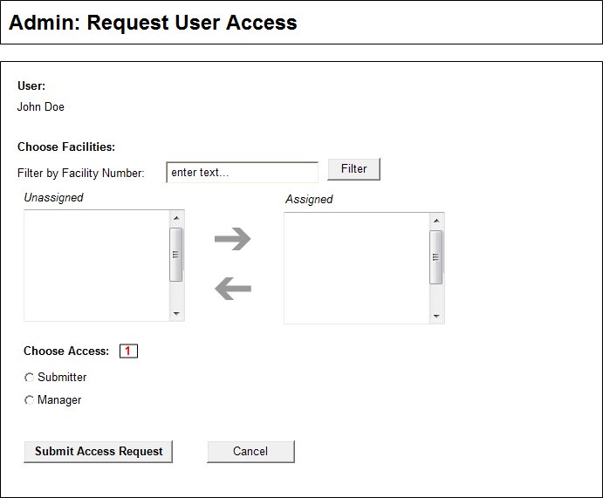

Upload Count Directions
Page Content and Business Logic:
Screen allows admin users to upload new count directions.
Functional Requirements:
- Screen is available to admins only
- Screen allows admin user to upload a new count directions file
- New file will be renamed by system to match previous file and will overwrite existing file. This allows the link for the directions to remain the same.
User Flow:
- Admin user clicks the View Existing Directions link to download a copy of the existing count directions.
- Admin user updates count directions and saves the file.
- Admin user browses for and selects the new count directions file.
- Admin user clicks the Upload Directions button to upload the new directions.
Fields and Buttons:
Field/Button | Comments | Required
View Existing Directions link | Links to the current count directions instructions. | No
Upload Count Directions | Field allows user to browse for and select the new count directions file. File must be in a predetermined file format (TBD) | Yes
Upload Directions button | Button uploads the selected directions file; system renames file to match the existing file’s name. | Yes

Navigation:
- Admin Nav
Screen Layout and Design:
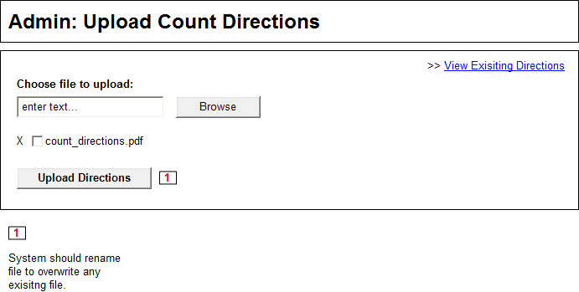

Bulk Data Upload
Page Content and Business Logic:
Screen allows admin users to upload bulk or historical data to the system using a provided template.
Functional Requirements:
- Screen is available to admins only
- Screen allows admin user to upload an Excel file that contains bulk or historical data into the system.
- Bulk upload can be used more than once.
User Flow:
- Admin user downloads the provided Excel template.
- Data is entered into template.
- Admin user uploads template.
Fields and Buttons:
Field/Button | Comments | Required
Bulk Data Excel Template link | Links to an Excel file that user can add data to. | No
Upload Bulk Data Template | Field allows user to browse for and select the template file. | Yes
Upload Bulk Data button | Button uploads the selected template file and adds the data to the application tables; system displays confirmation message. Only the provided Excel file can be uploaded. | Yes

Business Rules:
- Excel file should be not have its included columns altered in any way. The columns are set up to match the application data tables.
Navigation:
- Admin Nav
Screen Layout and Design:
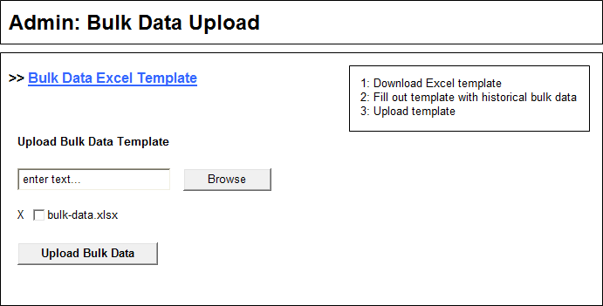

Admin View Data
Page Content and Business Logic:
Screen allows admin users to view the count period data from one or more facilities for a given count period.
Functional Requirements:
- Screen is available to admin users only
- Screen allows admin users to view the count data from a selected count period.
- Screen allows admin user to export the displayed data, refresh the cost data, and reject the count for a facility.
User Flow:
- User selects the view criteria from the Admin home screen.
- Screen displays the selected count data.
- Admin user can export the displayed data into an Excel file by clicking the Export to Excel button.
- Admin User can reject the count by clicking the Reject Count button.
- Admin user can refresh the cost information that has been captured by clicking the Refresh Cost button.
- Admin user can add data to the count by clicking the Add Data button.
- Admin user can search for items in the displayed data by keyword and column.
Fields and Buttons:
Field/Button | Comments | Required
Export to Excel button | Button exports the displayed data into an Excel file. | No
Refresh Cost button | Button recaptures the cost data for the selected count. | No
Reject Count button | Button displays a form that allows the admin user to enter in a reason for the rejection. System changes the status of the facility count to “Rejected Adm”, allows the count to be edited by submitters and managers, and emails all facility users. | No
Reject Reason Field | Field displays in a modal window if user clicks the Reject Count button. User types in the reason for rejection. Required if displayed. | Yes
Submit Rejection button | Button allows user to submit a rejection for the selected count sheet; system will display a confirmation alert (are you sure? Ok, Cancel); if Ok, system changes the status of the count sheet to Rejected ADM and sends an email to the facilities users. Field is required for rejection submittal. | Yes
Cancel button (From Rejection display) | Button cancels the Reject Count action. | No
Search Data | Field allows user to filter the data displayed by keywords and columns. | No
Search button | User enters a term, selects a filter, and clicks the Search button. The data will refresh and display only the filtered data. | No
Clear Filters button | Button removes all search terms and filters from the data, resetting the data display grid. | No
Add Data button | Button routes user to the Add Data screen, with the facility pre-selected. | No
Update Count Period button | Button updates the count period data; system displays a confirmation message and routes user to the Count Periods screen. | Yes
Sortable columns | Specified columns are sortable. Clicking the column header will sort the data by the selected column. | No

Business Rules:
- If data displayed is for a single facility in an Open count period, the following buttons display: Refresh Cost, Reject Count, and Add Data. If the data is for multiple facilities, or for a closed count period, these buttons should not display.
- If user clicks the Add Data button, the Add Data screen should have the selected facility preselected.
- All items with Remove=Y should be highlighted.
Navigation:
- Admin Nav
Screen Layout and Design:
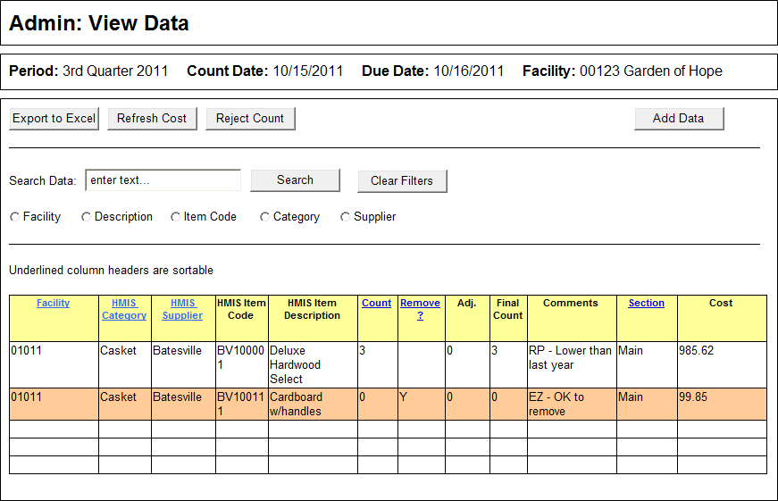
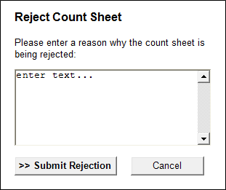

Admin Add/Update Items
Page Content and Business Logic:
Screen allows admin users to add new items or update existing items on the current cumulative open count sheet.
Functional Requirements:
- Screen is available to admin users only
- Screen allows admin users to add new items to a facility.
- Screen allows admin user to update an existing item assigned to a facility.
- Screen allows admin user to search for an item to add or update by several criteria.
User Flow:
- User clicks the Add/Update Data button from the Admin Navigation.
- Admin user types in a facility number, clicks tab, and then types in an HMIS Item Code and tabs again. The system will then display the HMIS Category, HMIS Supplier, HMIS Description, current count, and whether its set to be removed.
- Admin user enters a number in the Adj. field and enters any necessary comments in the Comments field and then clicks Add item button.
- If user does not know the HMIS Item code for an item they may search for the item by clicking the Search for Item button (see Search for Item for details).
- Admin user may edit or remove an item they just added by clicking either the Edit button or the Remove button. Items that were already assigned to the facility and that have been updated cannot be deleted-clicking Remove will only delete the update that the user has just made. If the user just added a new item that was not previously assigned to the location, clicking Remove will remove the item from the count.
- When the admin user has finished adding and updating items they will click the I’m Done Adding Items button, which will route them to the Admin home screen.
Fields and Buttons:
Field/Button | Comments | Required
Period text | System auto-displays the current open count period. | na
Count Date text | System auto-displays the current count period count date. | na
Due Date text | System auto-displays the current count period’s Due Date. | na
Open Date text | System auto-displays the current count period’s Open Date. | na
Search for Item button | System displays the Search for Item modal screen. | No
Facility field | Field allows user to type in a facility number. Field may be auto-populated if screen is accessed from the View Data screen and the data displayed is from a single facility. | Yes
HMIS Item Code field | Field allows user to enter an HMIS Item Code. | Yes
HMIS Category field | Upon tabbing out of the HMIS Item Code field, the system will use the item code to pre-fill the HMIS Category field. | Yes
HMIS Supplier field | Upon tabbing out of the HMIS Item Code field, the system will use the item code to pre-fill the HMIS Supplier field. | Yes
HMIS Item Description field | Upon tabbing out of the HMIS Item Code field, the system will use the item code to pre-fill the HMIS Item Description field. | Yes
Count field | Field displays the existing count for the current count period for the item if the item was already assigned to the facility. If the item was just added, the count will be zero. Field is not editable. | Yes
Remove? field | If the item was previously assigned to the facility the existing data for this field will display. If the item is new, field will be set to N. Field is not editable. | Yes
Adj. field | Field allows admin user to enter an adjustment value. Entered value will be used to generate the Final Count field (Count +- Adj = Final Count). Value entered may be positive (5) or negative (-5) whole numbers. Field has a default value of zero. | No
Final Count field | Field is auto-generated by system. Field uses the value entered into the Count field and adds it to the value entered into the Adj. field. This sum is the Final Count value. | na
Comments field | Field allows admin user to enter a comment for the item. | No
Section field | Field allows user to select which section the item should display in: Main, Special, or Inventory. An item can only display in one section per count sheet. | Yes
Add Item button | Button adds the item data to the Added/Updated Item listing. | Yes
Edit button | Button displays the selected item’s data in the add/update grid where the user can edit the item’s details. | No
Remove button | Button removes the selected item from the Added/Updated grid. | No
I’m Done Adding Items button | Button saves the item changes; system displays confirmation message and routes user to Admin home screen. | Yes
Cancel button | Button cancels the updates and routes user to Admin Home screen. | No

Business Rules:
- HMIS Item Code cannot be entered until a Facility number has been entered and tabbed out.
- If an item was added previously to a facility in error, the item should be brought up on this screen and a zero should be entered into the Adj. field (assuming no one has entered a count for the item over zero).
Navigation:
- Admin Nav
Screen Layout and Design:
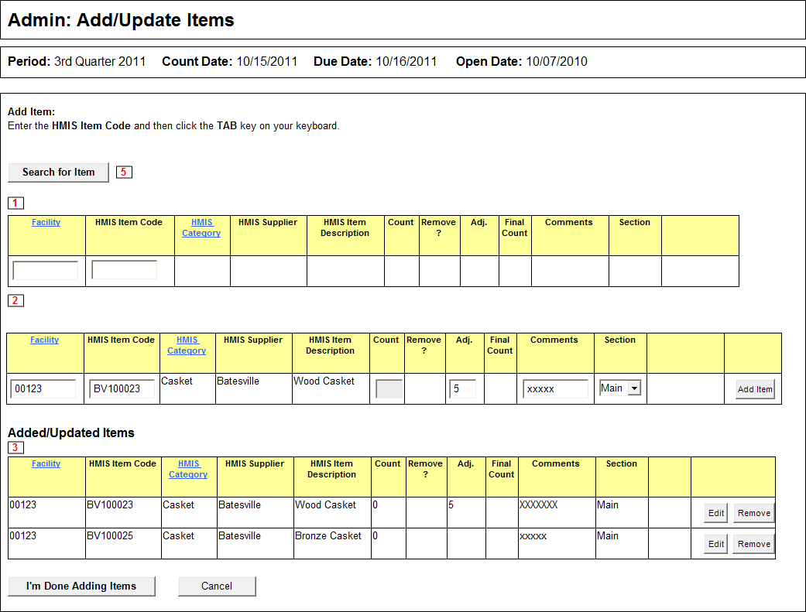

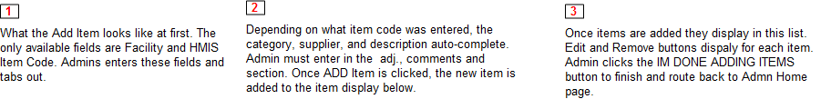

Search for Item
Page Content and Business Logic:
Modal screen allows user to search for an item to add to a count sheet for a pre-selected facility.
Functional Requirements:
- Screen is accessible from the Count Sheet Entry Additional Items tab screen and the Admin: Add Update Items screen.
- Screen allows users to search for an item by HMIS Category, HMIS Supplier, and/or keyword.
- Screen allows user to select an item to add to the Count Sheet Additional Items tab or the Add Update Items screen.
User Flow:
If Submitter/Manager from the Count Sheet Entry screen.
- User clicks Search for Item button on the Additional Items tab on the Count Sheet Entry screen.
- The Search for Items modal screen displays on top of the Additional Items tab.
- The facility for the open count sheet that the user is working in will be preselected and displayed on screen.
- User searches by one or more criteria: HMIS Category, HMIS Supplier, and Keyword. User clicks the Search button.
- All items that match the search parameters will display in a listing, with a Select button next to each item.
- User clicks the Select button next to an item that they want to enter to the Additional Items tab; system adds the item to the Additional items tab and then closes the modal screen.
If Admin from the Admin Add update Items screen.
- Admin user clicks the Search for Item button on the Admin Add Update Items screen.
- The Search for Items modal screen displays on top of the Admin Add update Items screen.
- Admin user selects a facility and then searches by one or more criteria: HMIS Category, HMIS Supplier, and Keyword. User clicks the Search button.
- All items that match the search parameters will display in a listing, with a Select button next to each item.
- Admin user clicks the Select button next to an item that they want to enter to the Admin Add update Items screen; system displays a confirmation alert (are you sure? Ok, Cancel); if Ok, system adds the item to the Admin Add update Items screen and then closes the modal screen.

Fields and Buttons:
Field/Button | Comments | Required
Facility | May be pre-selected and displayed on screen, or may be a selectable list. If list displays, field is required. | Yes
HMIS Category field | Field allows the user to filter by HMIS Category. The selected category from this list filters the HMIS Supplier list automatically. | No
HMIS Supplier field | Field allows user to filter by HMIS Supplier. Suppliers displayed in the list are pre-filtered by any selection in the HMIS Category field. Conversely, if the HMIS Supplier field is selected first, it will pre-filter the options in the HMIS Category field. | No
Keyword field | Field allows user to search for facility items by keyword. | No
Search button | Button allows system to search the selected facilities items by the selected criteria. | Yes
HMIS Category column | Column displays the HMIS Category names for all listed items returned in the search. | na
HMIS Supplier column | Column displays the HMIS Supplier names for all listed items returned in the search. | na
HMIS Item Code column | Column displays the HMIS Item Codes for all listed items returned in the search. | na
HMIS Supplier field | Upon tabbing out of the HMIS Item Code field, the system will use the item code to pre-fill the HMIS Supplier field. | na
HMIS Description Column | Column displays the HMIS Description for all listed items returned in the search. | na

Business Rules:
- If the user is clicking the Search for Items button from the Additional Items tab, the Facility should be preselected and should display on screen.
- The HMIS Category and HMIS Supplier droplists should only list options that are available for the selected facility.
Navigation:
- Admin Nav or User/Submitter nav

Screen Layout and Design:
Admin Users:
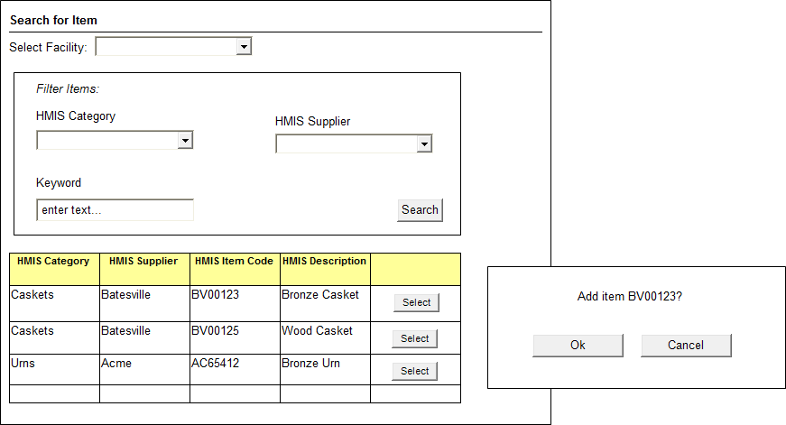
From Additional Items Tab:
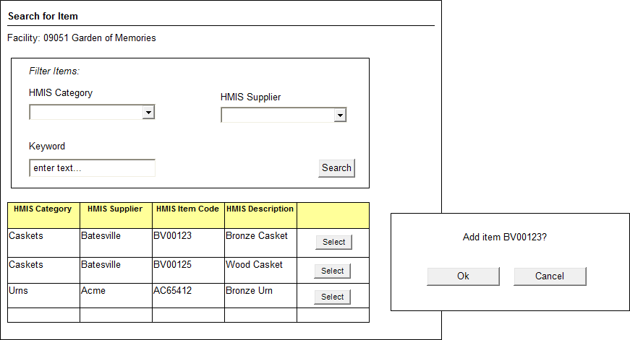

Change Log:
Date | Change
5/11/2010 | Updates per Jesse.

